Jenkins

- How can you implement parallel execution in a Jenkins pipeline?
In a declarative pipeline, use the parallel block to run multiple tasks simultaneously, reducing build time. For example:

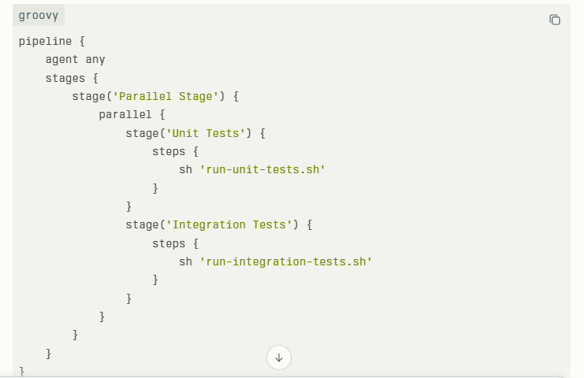

- What are declarative and scripted pipelines?

What are declarative and scripted pipelines? Declarative pipelines have a predefined, simpler structure focusing on readability and maintainability. They use pipeline {} syntax.
Scripted pipelines are written in Groovy with more programming flexibility, allowing complex logic.
Example (Declarative):

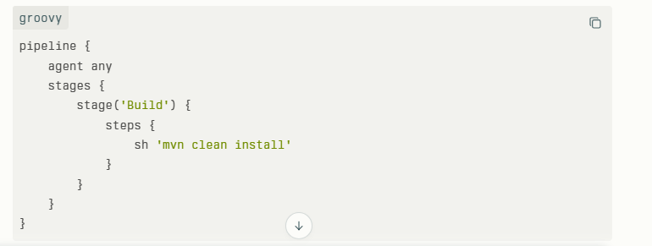

- How do you manage credentials securely in Jenkins?

Jenkins has a built-in credentials store where sensitive data like passwords and tokens are saved securely. You add credentials via Manage Jenkins > Manage Credentials and reference them in jobs using variable bindings.

withCredentials([usernamePassword(credentialsId: 'my-credential-id', usernameVariable: 'USER', passwordVariable: 'PASS')]) {
sh 'curl -u $USER:$PASS https://mysecureapi.example.com'
}

- What is the purpose of the Jenkinsfile and how do you use it?

A Jenkinsfile is a simple text file that holds the step-by-step instructions for automatically building, testing, and delivering your software. It lives in your project’s code repository so the process is always saved, easy to update, and shared with the whole team. Jenkins reads this file to know exactly what to do whenever you want to run your pipeline.

- How can you trigger a Jenkins job from an external source?
To trigger a Jenkins job from an external source, you can use Jenkins' remote build feature. This means you send a special HTTP request (like a web call) to Jenkins, telling it to start a particular job.
Here’s a simple way to do it:
In Jenkins, enable the option "Trigger builds remotely" for the job.
Set a security token (a password-like key) for this trigger.
From an external system or script, send an HTTP request to a URL like:
text
http://jenkins-server/job/job-name/build?token=your-token
Jenkins receives this request and starts the job automatically.
This is helpful when you want to start Jenkins jobs from another tool, a script, or after a code change in a repository.
Example curl command to trigger:
text
curl -X POST http://jenkins-server/job/myjob/build?token=abc123
If your job needs parameters, there are additional URL forms to include them.
This method allows automated, remote control of Jenkins builds without manually clicking in the Jenkins interface. It’s commonly used to integrate Jenkins with other systems and automate workflows easily.
- How do you handle build failures in Jenkins?
-- Analyze build logs to identify errors.
-- Use tools like the “Build Failure Analyzer” plugin.
-- Set up email or Slack notifications on failures.
-- Automate retry strategies or manual intervention workflows.

- How do you create and manage build pipelines in Jenkins?
Pipelines are created using Jenkinsfile with stages and steps. You define stages (e.g., build, test, deploy) and use SCM integration for source control.

- What steps would you take if a Jenkins build is stuck in the queue?
Check resource availability and executor status. Free up or add more executors/nodes as needed.

- How do you optimize Jenkins for large-scale environments?
Use distributed builds with multiple agents, utilize parallel builds, and modularize pipelines using shared libraries to improve efficiency and scalability.

- What is the purpose of Jenkins worker node
A worker node in Jenkins is a separate machine (or server) that runs build jobs assigned by the Jenkins master. It helps distribute work so multiple jobs can run at the same time without overloading the master. This makes Jenkins faster and more scalable. The master controls and schedules the jobs, and the worker node actually executes them. This setup allows using different machines or environments to run builds efficiently.

- What is agent in Jenkins

In Jenkins, an agent is the machine or process that runs the build or automation tasks given by the Jenkins master (controller). It connects to the master and executes jobs such as building code, running tests, or deploying applications. Agents allow Jenkins to distribute work across multiple machines, speeding up the process and enabling parallel execution. Simply put, an agent is the worker that does the actual job under the master’s control.

- Worker node configuration

Step 1: create one worker node (server)

Step 2: Java version should be same in both master and worker-node.

Step 3:

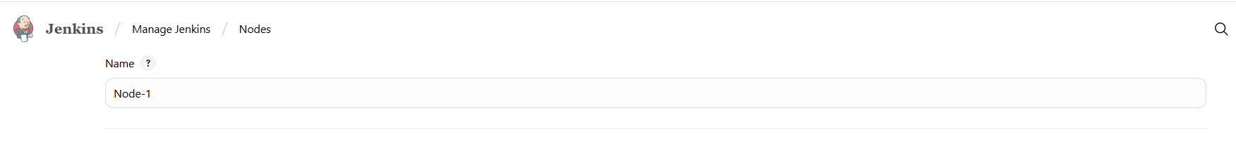

- Here, we have to give the name of node for example: node, worker node

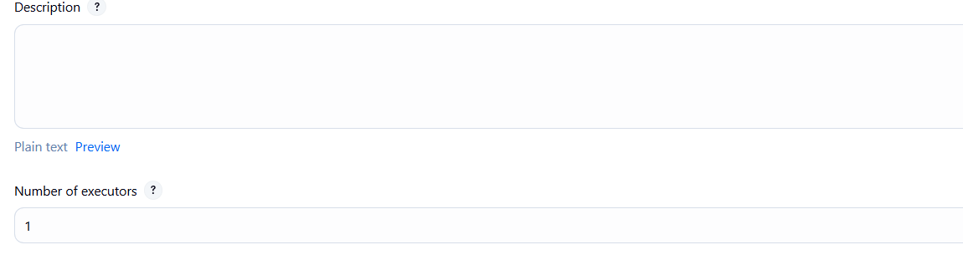
This means parallel how many job should run

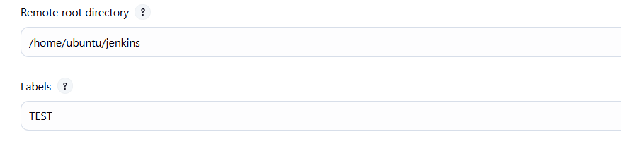
Remote root directory means. We have to create one folder (jenkins) in side server of worker node.

Labels: means which environment pipeline should for example dev ,test,prod. So we can maintain separate pipeline for each environment.
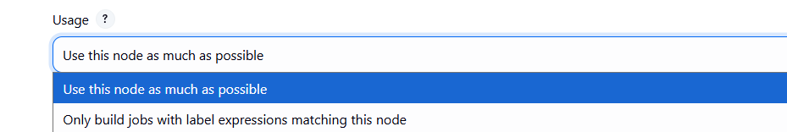

This name itself saying that we can use this node as much as possible or only build jobs with label expression matching this node.

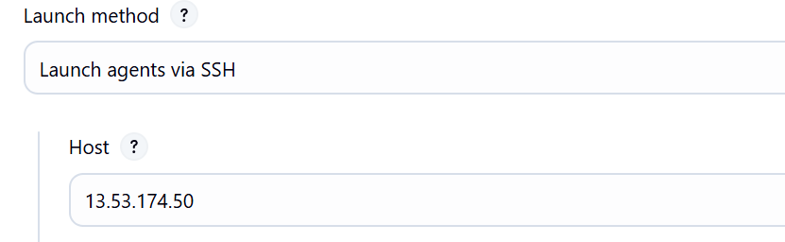

Here we have to mention the private IP address of the worker node server

We have to take the private Ip of the Node server and place it in host.

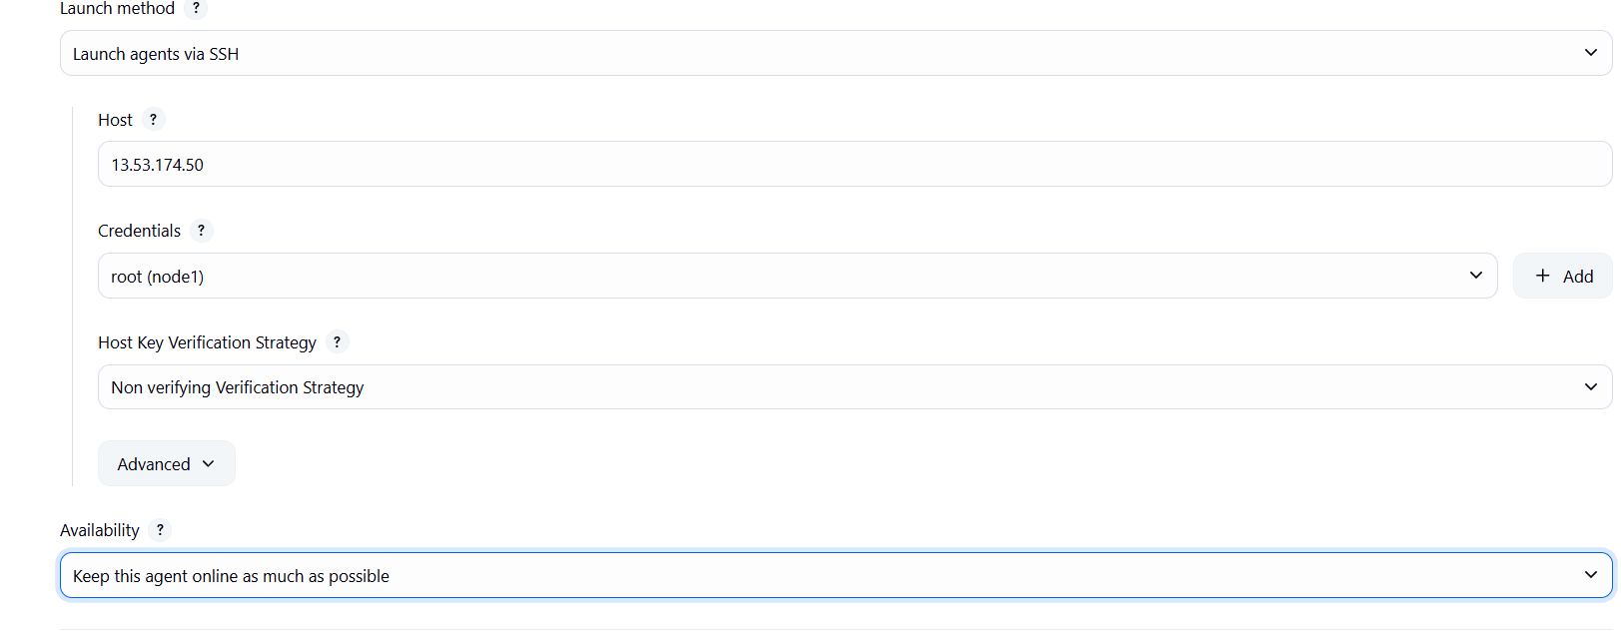

We have to configure the credential part
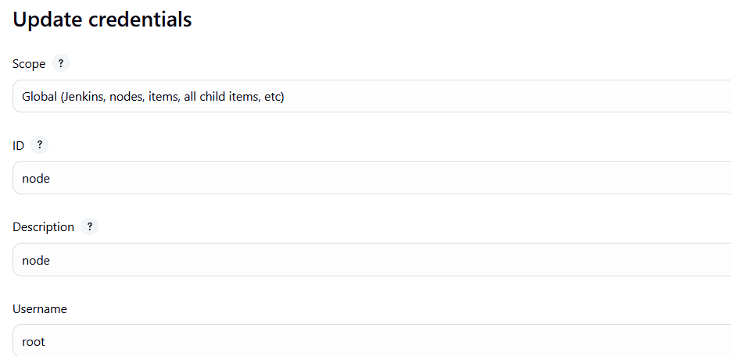

User is root because we have create the jenkins file in node server as a root user

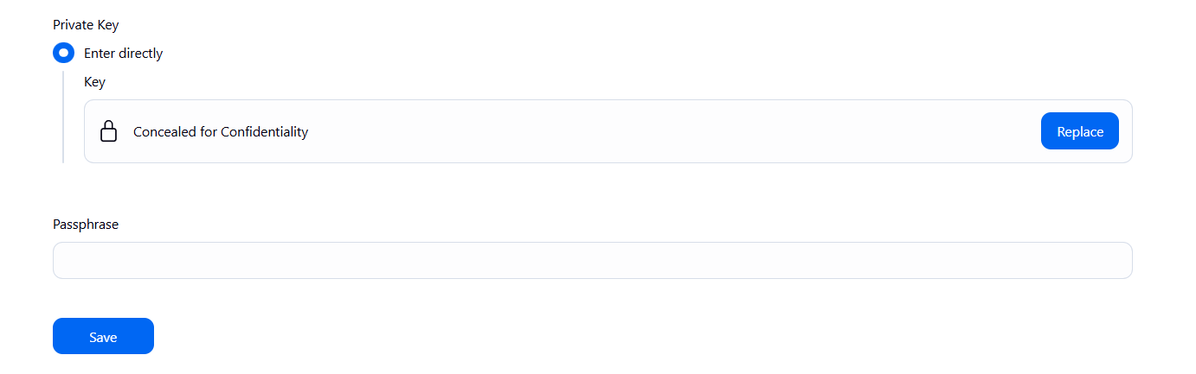

Here , we have to store the private of the worker node .

Note :

We have to mention which node should run . we can create a node for each environment

agent
{
lable: 'Prod'
}

How do you troubleshoot slow Jenkins pipelines?
Identify bottlenecks by analyzing logs, optimizing build steps, using parallel execution, distributing workloads across agents, and cleaning up unnecessary steps or artifacts.

What are some best practices for Jenkins pipeline security?
Use role-based access control, limit script approvals, keep plugins up to date, secure credentials, and run Jenkins with the least privileges necessary.

